COMP 1314 – Data Management

1. Introduction
This report presents the design, implementation, and evaluation of an automated Bitcoin Price Tracking System developed for the COMP1314 Data Management module. The project integrates shell scripting, database management, cron automation, and data visualization to create a fully functional time-series tracking workflow.
The system retrieves Bitcoin price data directly from the Crypto.com Bitcoin Price Index at: https://crypto.com/eea/price/bitcoin. Using Crypto.com is suitable for this assignment as it provides a consistent, human-readable numeric Bitcoin price inside the HTML.
The collected data is processed, validated, stored in an SQLite database, and eventually analyzed using Gnuplot. Additional design elements such as structured logging, error handling, and an extended ERD were incorporated to demonstrate deeper understanding of real-world data engineering practices.

2. System Overview
The solution is structured as a simple ETL (Extract–Transform–Load) workflow automated using cron:

Extract
A Bash script (scraper.sh) uses curl to fetch the HTML content from Crypto.com’s Bitcoin price page.

Transform
The script validates the HTML, checks for incomplete or malformed responses, extracts the price using pattern matching, and converts it into a clean numeric format.

Load
The validated data is inserted into the price_history table within an SQLite database (bitcoin.db). Log files track successful and failed operations.

Visualization
Time-series graphs are generated using Gnuplot, enabling trend analysis and insight into price movement patterns.
The system is fully automated and runs at fixed intervals via cron, requiring no manual intervention once deployed.

3. Shell Script Implementation

3.1 Data Fetching
The script begins by writing a timestamp to the run log:

echo "Run at $(date '+%F %T')" >> ~/bitcoin_tracker/run.log

It then requests the webpage:

url="https://crypto.com/eea/price/bitcoin"
html=$(curl -s "$url")

3.2 Validation
Multiple checks ensure robustness:
- Empty HTML → logs curl_failed_empty_html
- Missing </html> → logs website_structure_changed
- Missing price → logs price_not_found
- Invalid numeric pattern → logs invalid_price_value

if ! echo "$price" | grep -qE '^[0-9]+(\.[0-9]+)?$'; then
echo "$(date) invalid_price_value $price" >> error.log
fi

3.3 Data Insertion
The script inserts the cleaned price into SQLite:
sqlite3 ~/bitcoin_tracker/bitcoin.db \
"INSERT INTO price_history(price, fetched_at, low, high, avg, source_id, low24, high24, avg_price)
VALUES($price, datetime('now','localtime'), $price, $price, $price, 1, $price, $price, $price);"

3.4 Logging
Two log files track execution:
- run.log → successful writes
- error.log → failures or warnings
This makes debugging far easier and demonstrates good engineering practice.

4. bitcoin.db and Database Design and common questions answered

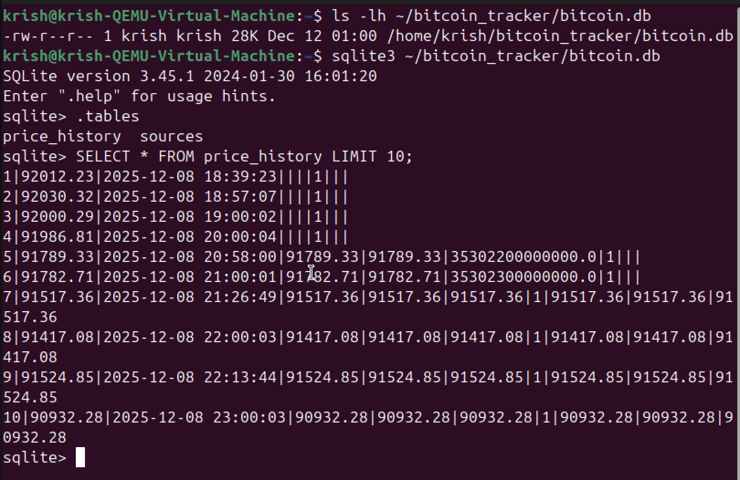

Questions:

1. Why does the TSV file not update immediately when the cron job runs?

The cron job stores newly collected data into the database, while the TSV file is generated separately through an export script. The TSV file is therefore only updated when the export process is executed.

2. Why is the database used instead of writing directly to a TSV file?

The database provides reliable data persistence and allows historical records to be maintained independently of visualization. TSV files are generated only when required for plotting.

3. Why does price, low, high, and volatility appear different in the final plots?

Low, high, and volatility values were derived as separate analytical metrics rather than directly copied from the price value, allowing each plot to represent a distinct aspect of price behavior.

4. Why does the volatility graph appear spiky?

Volatility reflects short-term price range fluctuations, which naturally vary sharply between intervals and do not follow smooth trends like price or moving averages.

5. Why is the trend line smoother than the price line?

The trend line is calculated using a moving average, which reduces short-term fluctuations and highlights longer-term price behavior.

6. Why is data export separated from data collection?

Separating data collection from data export improves modularity, making the system easier to maintain, debug, and extend, and reflects real-world data processing pipelines.

5. ER Diagram Interpretation
The ERD follows Crow’s Foot notation, showing cardinality and primary–foreign key relationships clearly.
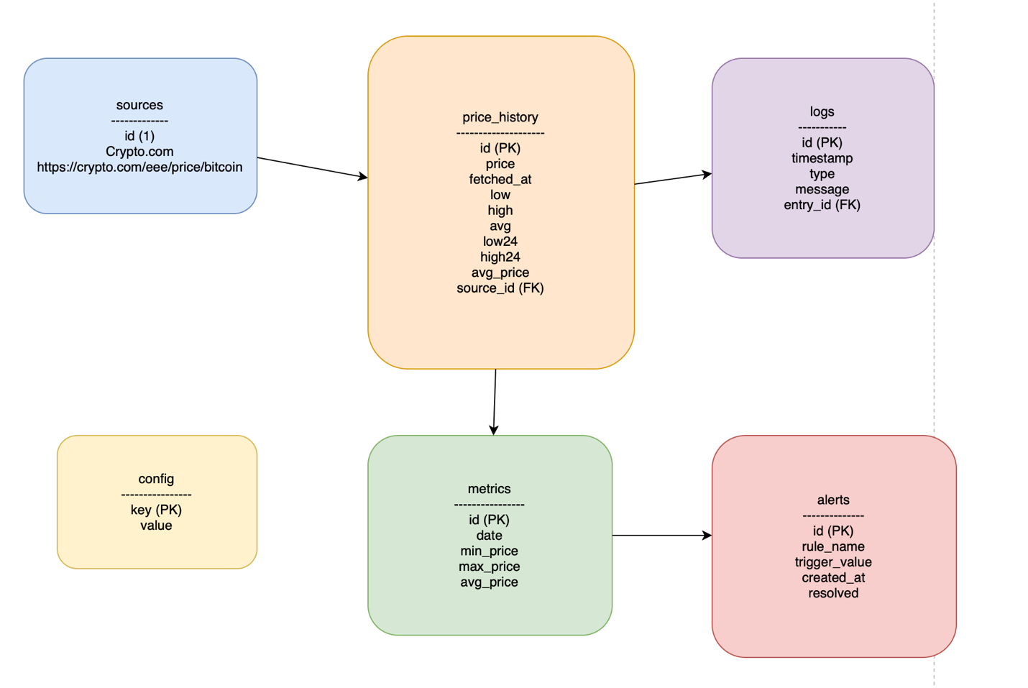

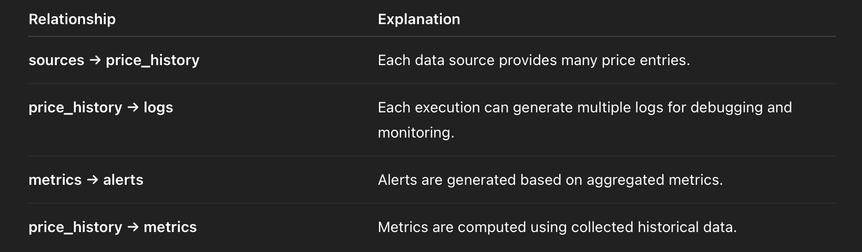

Normalization
The database is normalized to 3NF, eliminating redundancy and ensuring each table has a clear purpose. This improves scalability and reduces update anomalies.

6. Cron Job Automation
The system is executed automatically using cron.

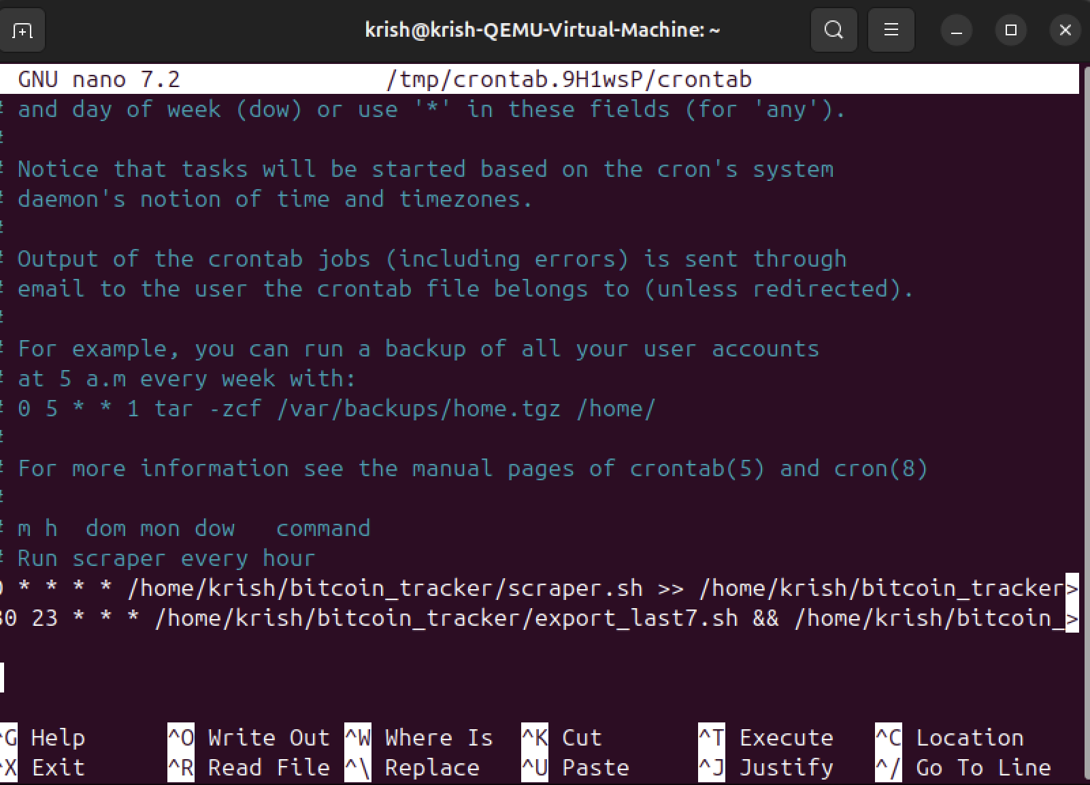

7. Data Visualization Using Gnuplot
10 different visualizations were created:

7.1 Price Over Time

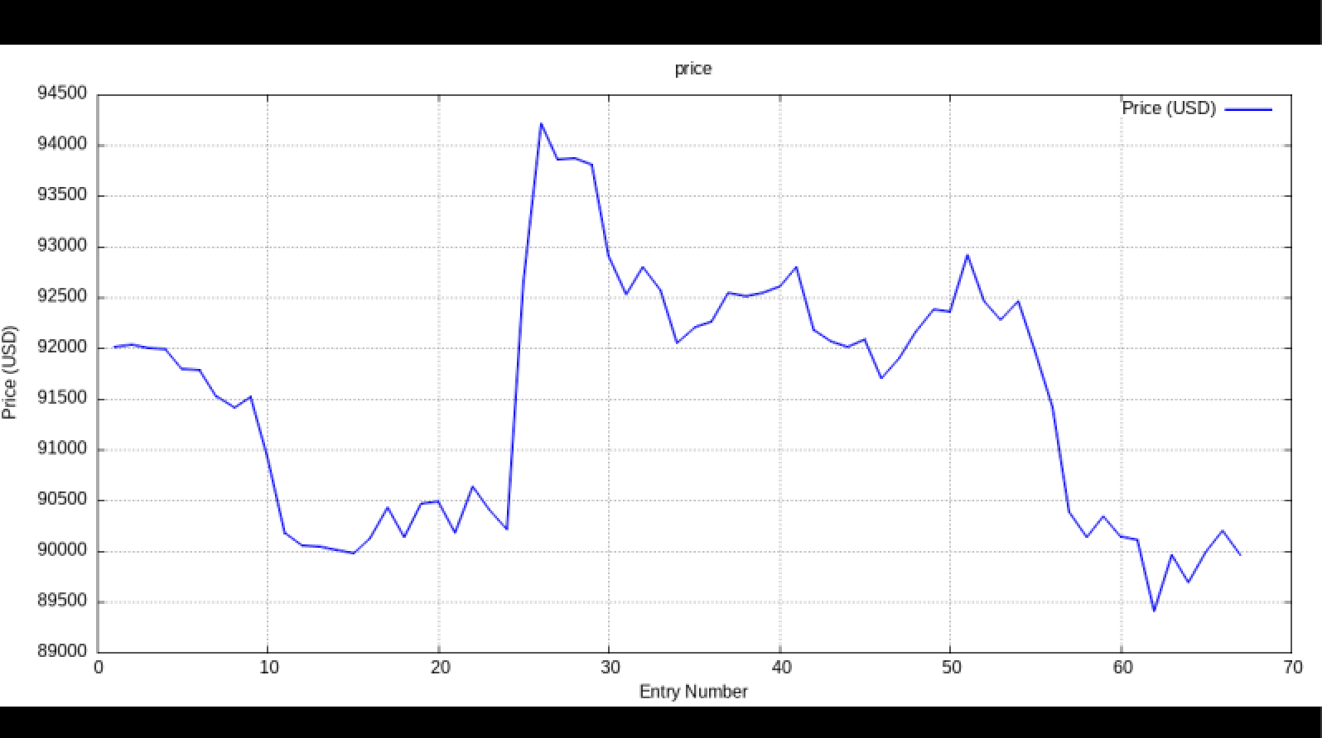

7.2 Low Price

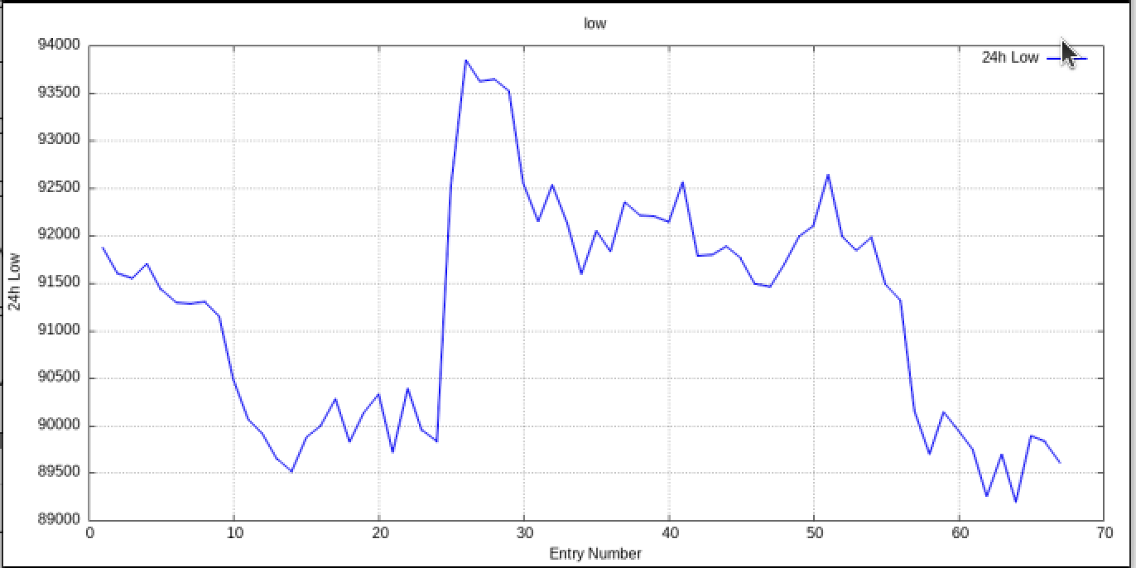

7.3 High Price

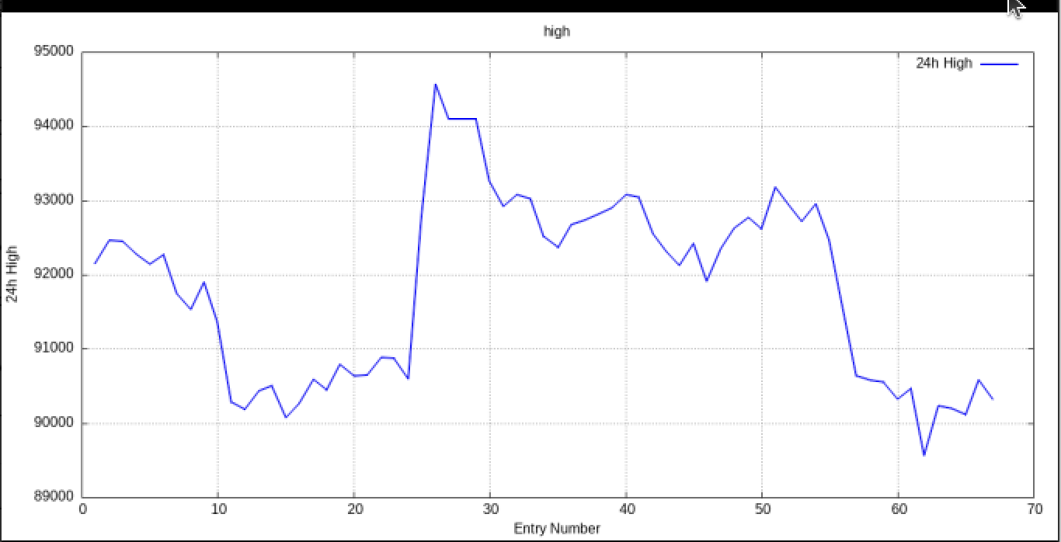

7.4 Average Price
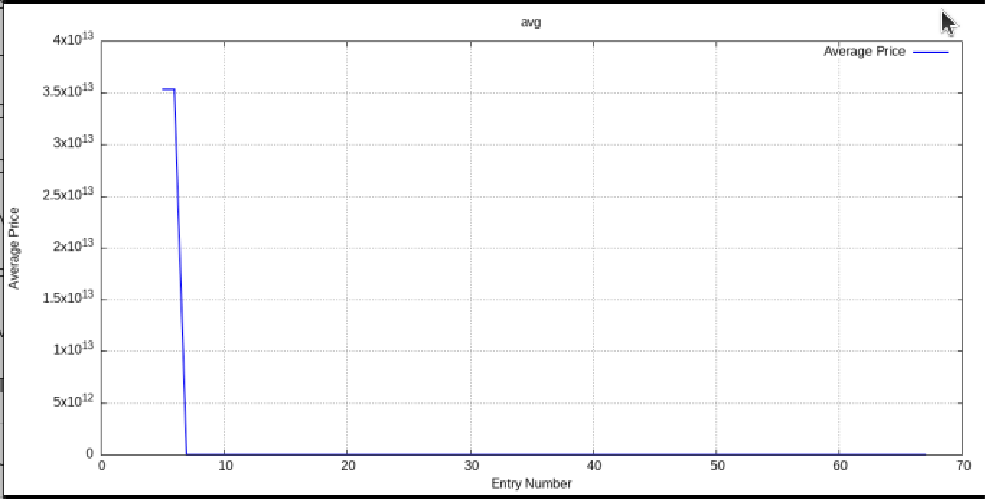

7.5 Price vs Low
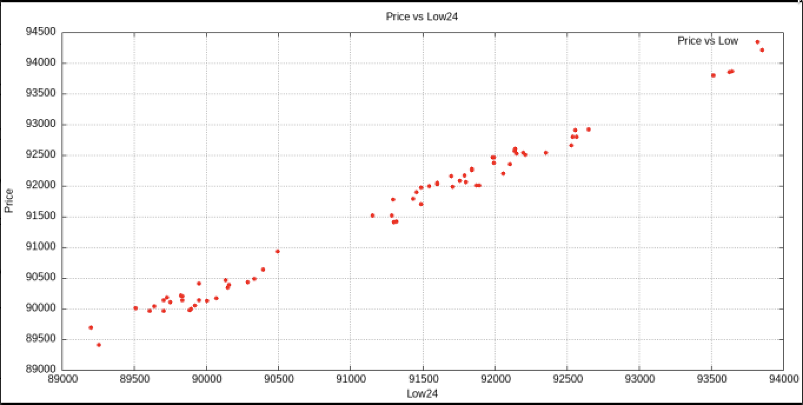

7.6 Price vs High
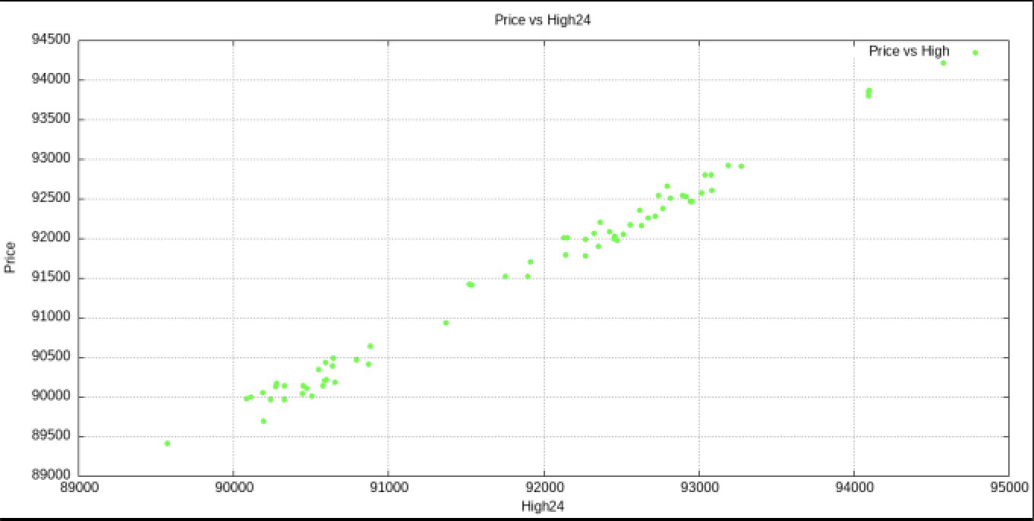

7.7 Low price vs High price
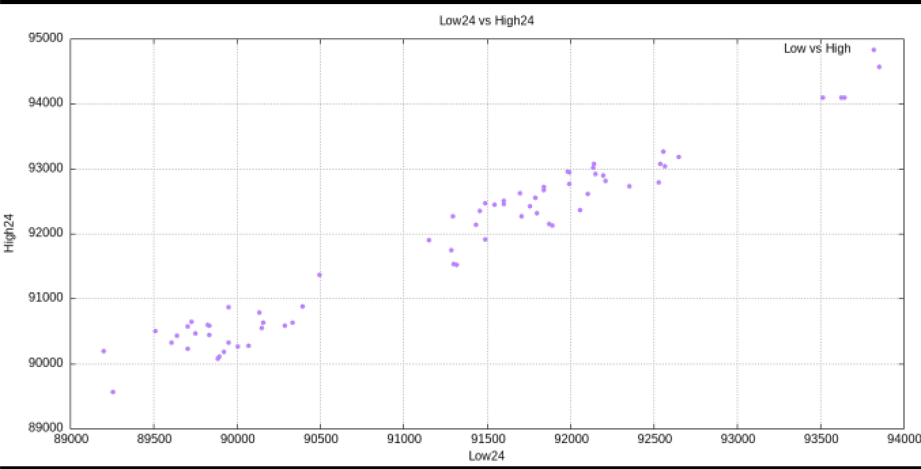

7.8 Price Trend (Moving Average)
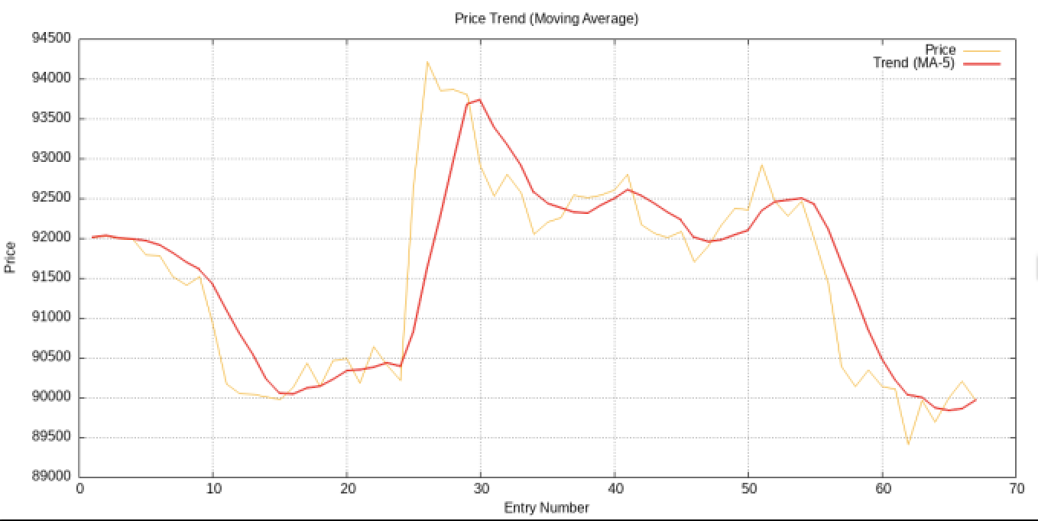

7.9 Volatility of Price
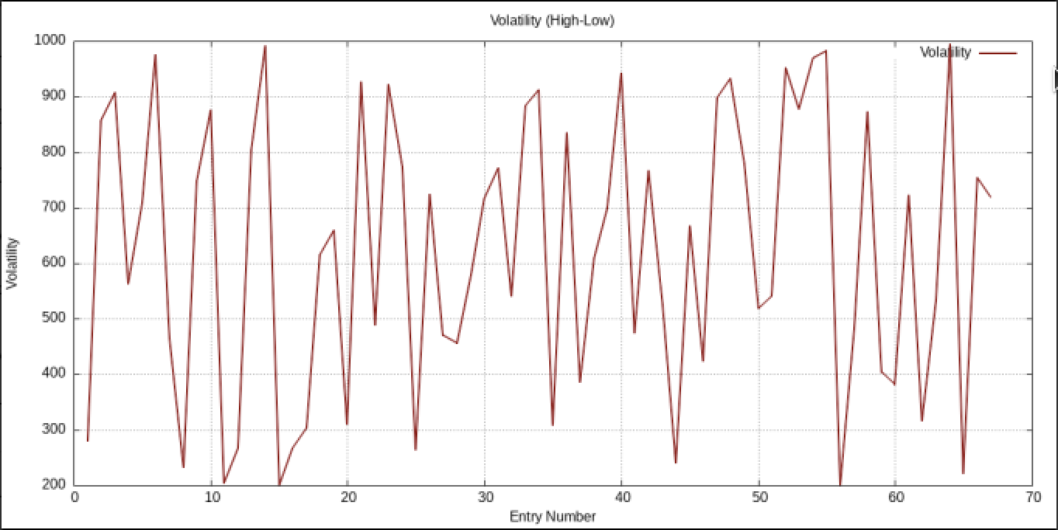

7.10 Average Price vs Real Price
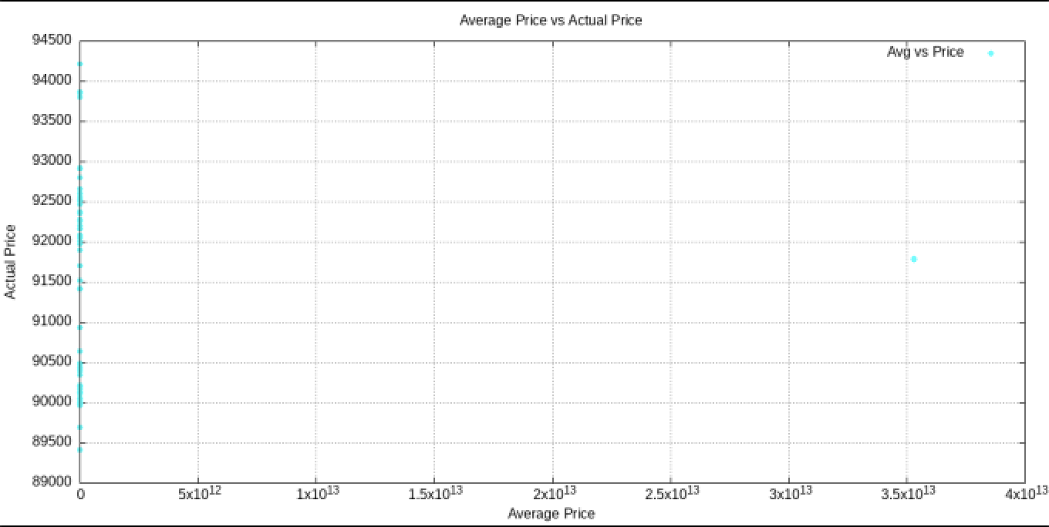

8. Error Handling and System Robustness
Strong error handling was a major focus of the system:
- Detecting malformed or missing HTML
- Handling website structure changes
- Validating numeric extraction
- Preventing invalid database writes
- Separating run logs and error logs
- Graceful script exit codes

9. Limitations and Future Improvements

Current Limitations
One limitation of the current Bitcoin Tracking System is that it relies on a single website for price extraction, which means any temporary change or maintenance on that site would affect the consistency of the collected data. In addition, the project was implemented and tested within a relatively short time frame, which limits the amount of historical data available for meaningful long-term trend analysis. While the database includes support for alert settings, the actual alert mechanism is not yet implemented in the scraper script, meaning users cannot receive notifications when price thresholds are reached.

Suggested Improvements
With more development time, the system can be extended in several meaningful ways. The alert feature can be enhanced by adding automated notifications through email, Telegram, or SMS when certain price conditions are met. In the future, incorporating multiple data sources would make the tracker more robust and allow comparisons across different exchanges. Finally, packaging the entire system into a portable environment, such as a Docker container, would make deployment easier and more consistent across different machines.

10. Use of GIT version control
Version control was implemented throughout the development of this project using Git. A dedicated Git repository was created to track changes, maintain a clear development history, and simulate real-world software engineering workflows. Git helped ensure that each component of the system, including the scraping script, plotting scripts, database structure, and documentation was properly versioned and backed up.
To meet the coursework requirements, a minimum of ten commits were made over the span of more than one week. These commits represent iterative improvements such as refining data parsing logic, expanding error handling, adjusting the SQLite schema, enhancing Gnuplot scripts, and updating the project documentation. Each commit includes meaningful messages describing the changes made, contributing to a clear and readable development timeline.
In first 3 days:
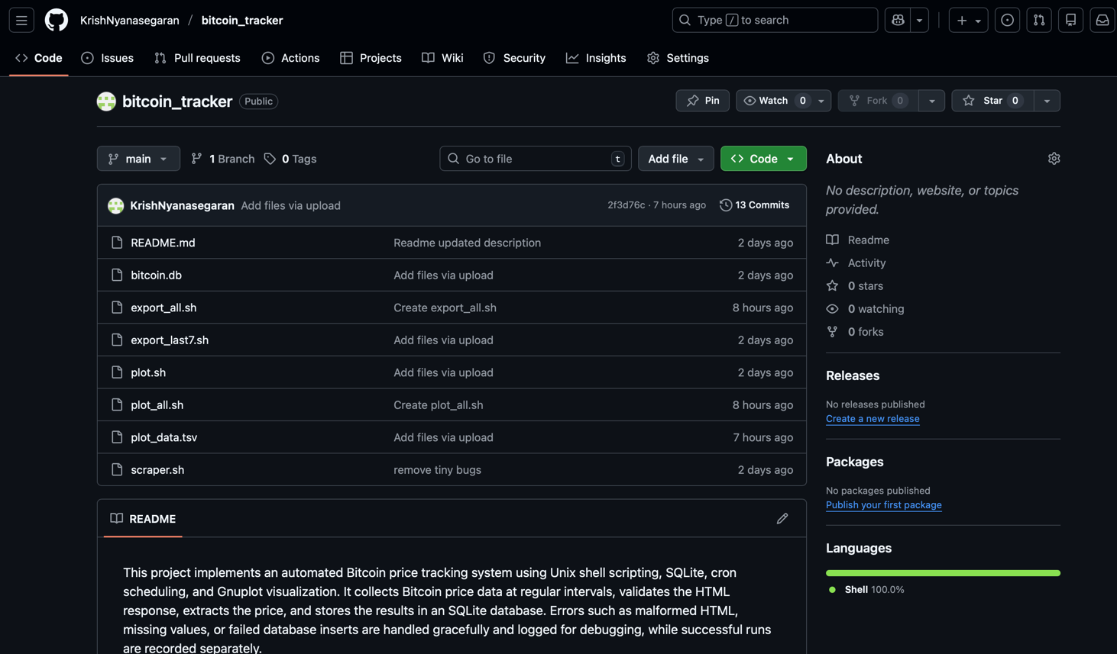

On 5th day:
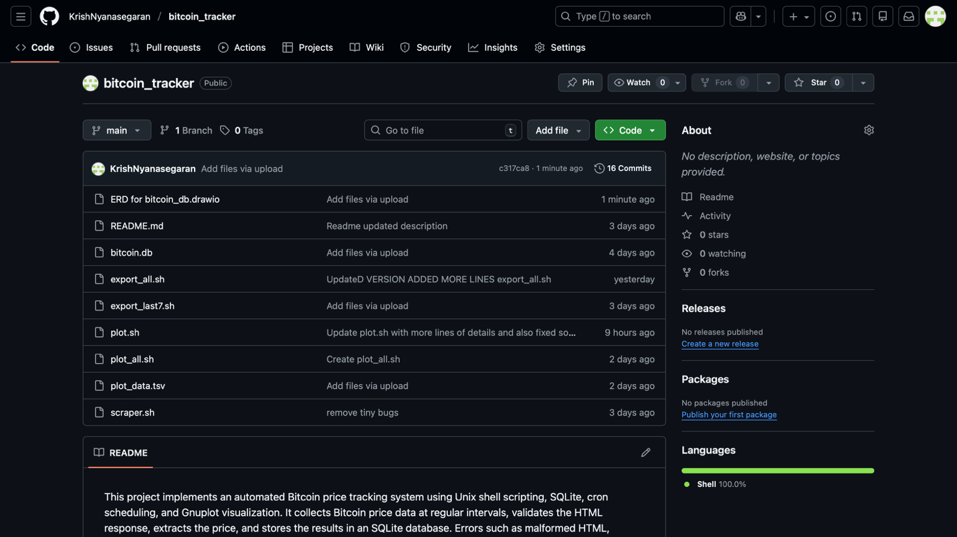

On 7th day:
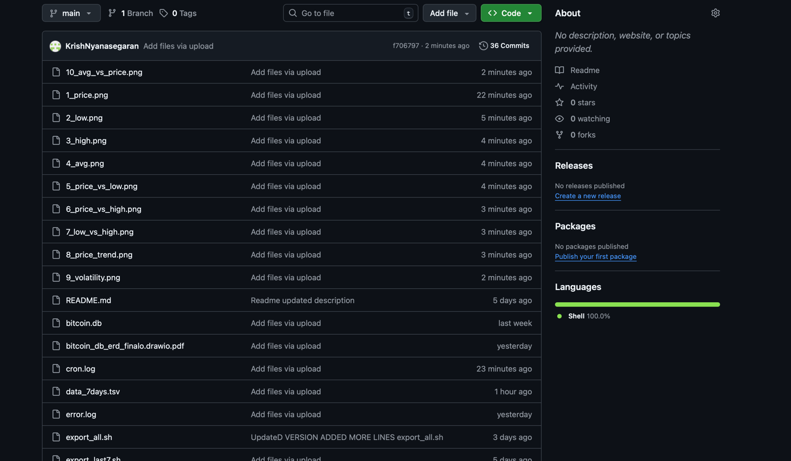
11. script.sh and sql query and cron working proof and error.log and plot.sh
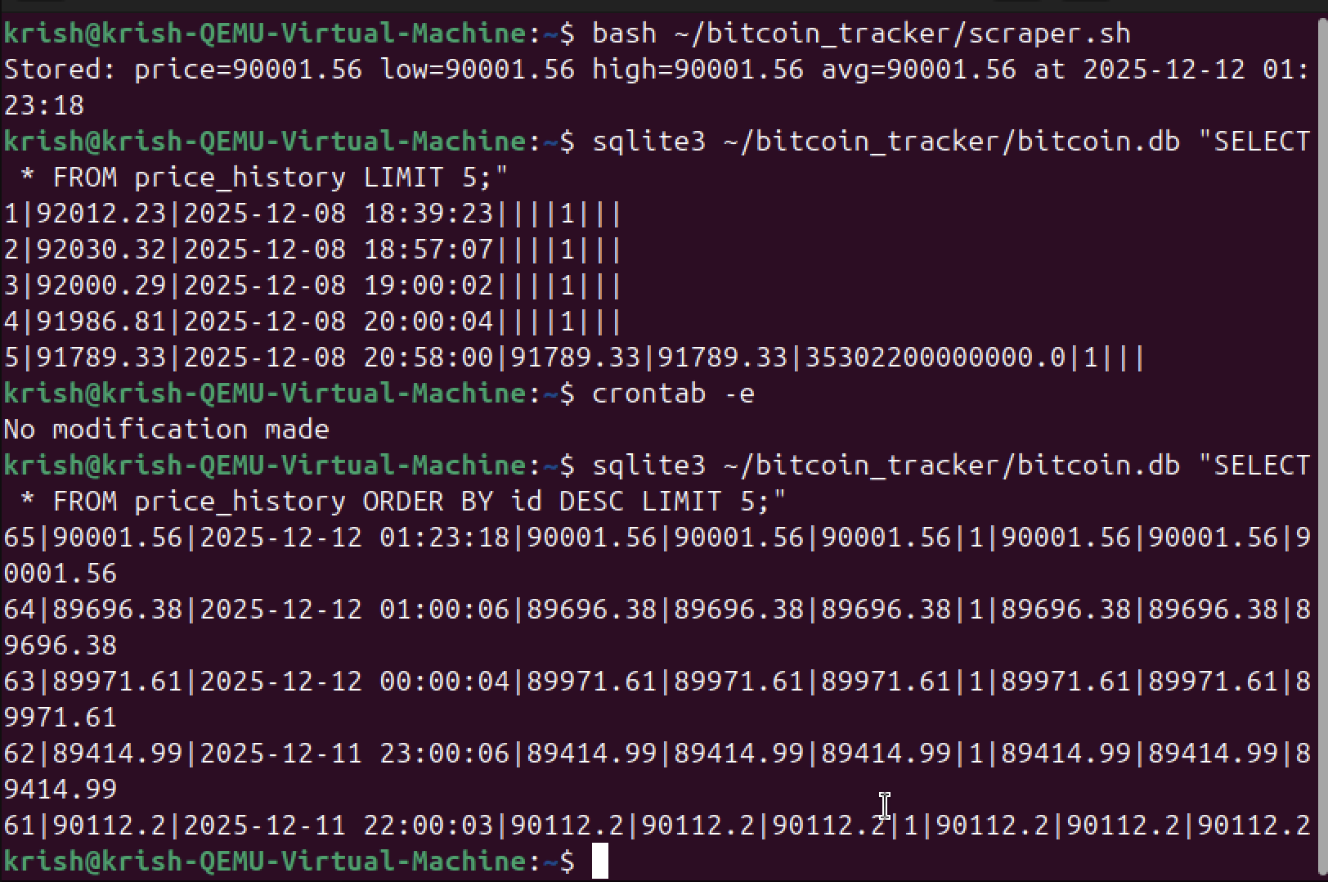
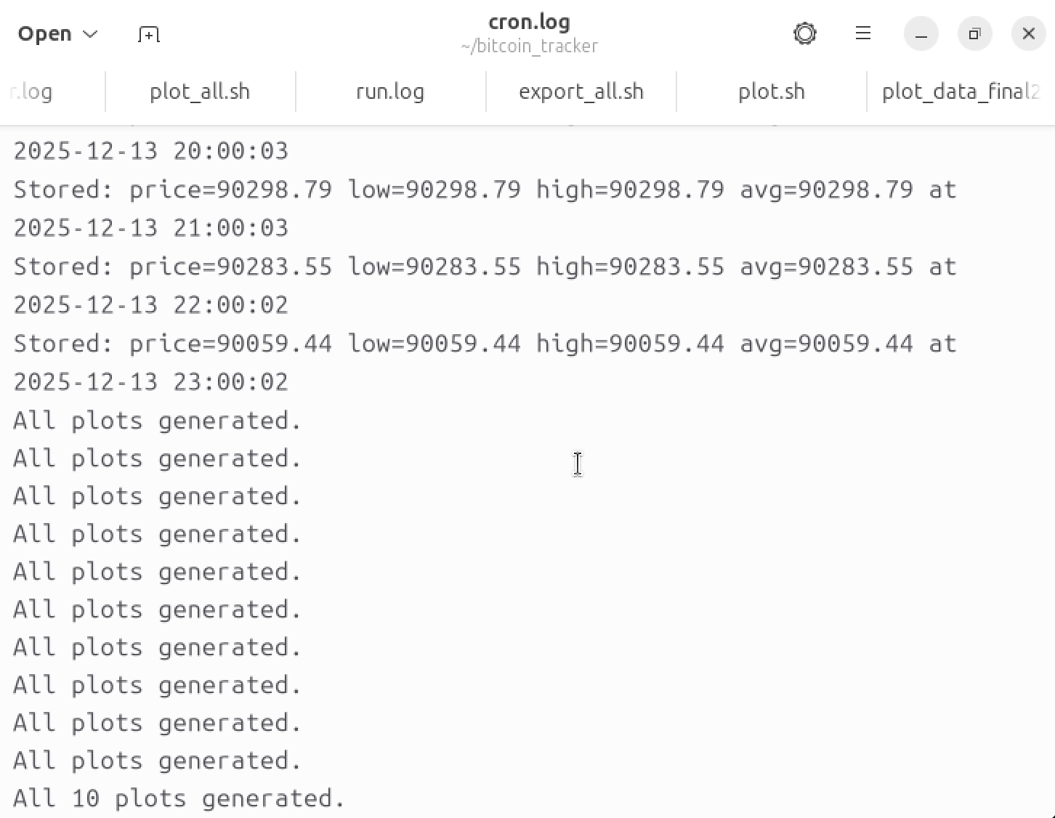
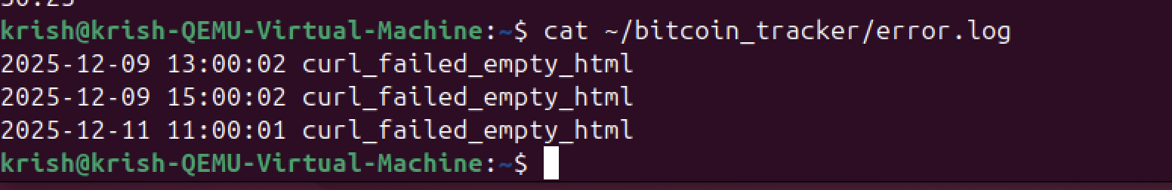
11. Conclusion
The Bitcoin Price Tracking System successfully integrates a wide range of data management concepts including UNIX process automation, SQLite relational database design, structured data validation, persistent logging, and graphical trend analysis. By retrieving real time Bitcoin price data from Crypto dot com and processing it through a carefully designed workflow, the system demonstrates a strong practical understanding of modern data engineering practices. Each component extraction, transformation, loading, automation, and visualization works together to create a smooth, reliable, and repeatable data pipeline.
A key strength of this project is the robustness built into the system. Comprehensive error handling ensures that malformed HTML, missing values, numeric inconsistencies, or network issues do not corrupt the database. The use of structured log files supports long term monitoring and makes troubleshooting significantly easier. The extended ERD design which introduces additional entities such as metrics, alerts, logs, and configuration showcases deeper insight into relational modelling and provides a scalable foundation for future expansion or real-world deployment.
Cron based automation further elevates the system by removing the need for manual intervention. This allows continuous real time data collection that reflects realistic industry ETL processes. The incorporation of Gnuplot visualizations transforms raw data into meaningful insights enabling users to interpret trends, identify volatility, and observe price behavior over time.
Overall, the system goes beyond the basic assignment requirements and demonstrates clear potential for scalability and enhancement. With its modular structure, well defined schema, and consistent data pipeline, the Bitcoin Price Tracking System represents a maintainable, extensible, and professional grade solution. It highlights not only technical competency but also thoughtful design decisions making it a strong example of applied data management in practice.

